6A^{th} Grade: Unit 7, Lesson 1

- What is the height of the triangle shown?
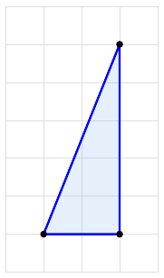
5 units

- What is the area of the rectangle shown?
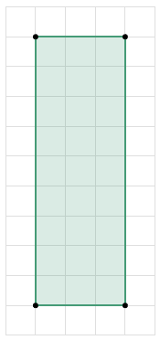

27 units

- Which triangle is acute?
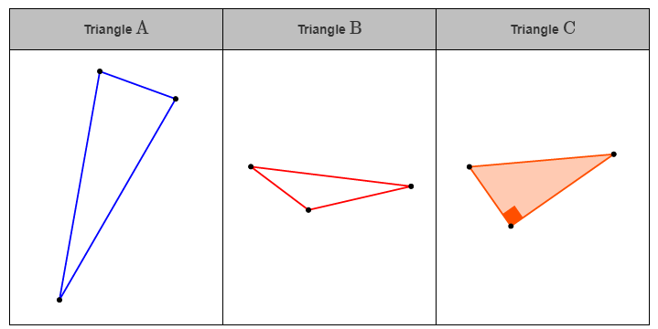
Triangle A

